Source Code for the given blackbook can be downloaded from https://wordpress.library-management.com/
Or
For a advanced version of library source code can be downloaded from
https://library-management.com
A PROJECT
ON
LIBRARY MANAGEMENT SYSTEM
Submitted by
Mr. Random Name (0000000)

Year 2016-2017

DATE OF SUBMISSION
06-06-2017

Under the guidance of Mr.Random Sir Name

Submitted in partial fulfillment of the requirements for qualifying M.C.A Semester VI Examination

INSTITUTE OF DISTANCE AND OPEN LEARNING

UNIVERSITY OF MUMBAI
DR. SHANKAR DAYAL SHRAMA BHAVAN,
VIDYANAGARI, SANTACRUZ (E), MUMBAI-98

A PROJECT
ON
LIBRARY MANAGEMENT SYSTEM
Submitted by
Mr. Random Name (0000000)

Year 2016-2017

DATE OF SUBMISSION
06-06-2017

Under the guidance of Mr.Random Sir Name

Submitted in partial fulfillment of the requirements for qualifying M.C.A Semester VI Examination

INSTITUTE OF DISTANCE AND OPEN LEARNING

UNIVERSITY OF MUMBAI
DR. SHANKAR DAYAL SHRAMA BHAVAN,
VIDYANAGARI, SANTACRUZ (E), MUMBAI-98

INSTITUTE OF DISTANCE AND OPEN LEARNING

UNIVERSITY OF MUMBAI, IDE BUILDING,
VIDYANAGARI, MUMBAI-98

PROJECT CERTIFICATE

This is to certify that the Project titled Library Management System_ by
Mr. Random Name Seat No 00000000 in partial fulfillment for M.C.A Degree Examination in Semester VI for the academic year 2016-2017 has been found satisfactory. This report had not been submitted for any other examination and does not form part of any other course undergone by the candidate.

Signature | Signature | Signature
Faculty in charge | External Examiner | Coordinator – M.C.A (IDOL)
Guided by | Examined By | Certified By

DECLARATION

I declare that this written submission represents my ideas in my own words and where others' ideas or words have been included, I have adequately cited and referenced the original sources. I also declare that I have adhered to all principles of academic honesty and integrity and have not misrepresented or fabricated or falsi ed any idea/data/fact/source in my submission. I understand that any violation of the above will be cause for disciplinary action by the Institute and can also evoke penal action from the sources which have thus not been properly cited or from whom proper permission has not been taken when needed.

(Signature)
Random Name

Date :

ACKNOWLEDGEMENT

I the undersigned have great pleasure in giving our sincere thanks to those who have contributed their valuable time in helping us to achieve the success in our project work.
I would like to express our gratitude to all those gave us the possibility to complete this project. I want to thank St Stefen High School for giving us the opportunity for doing this project.
I am indebted and thankful to our Project Guide Prof. Mr.Random Sir Name
to whom I owe his piece of knowledge for his valuable and timely guidance, co-operation, encouragement & time spent for doing this project work.
My sincere thanks to the IT staff for providing us sufficient information which helped us to complete our project successfully.

PREFACE

Computers are now becoming part of almost every activity in organization. The developments made on the fields of information and computer technology have vastly blown up and have changed the face of the present world rapidly. The use of IT has gradually and now computers are increasingly used for everyday activities organizations. The Library Management System is full of feeling to provide better services to its users.
The main objective of the program is too serve the library to handle day to day books transaction and maintain sound information about the books as well as the members.
I want to express my gratitude to Mr.Random Friend Name for his valuable guidance for accomplishing this project entitled “LIBRARY MANAGEMENT SYSTEM”.
My sincere thanks also goes to the friends who have suggest the flow of the system and gave reliable ideas to work on.
I have worked with commitment right from the initialization of the project and continuing all the way till its compilation.
Review of the project is an unending process and it may contain errors as there is always a scope for improvements.

SYNOPSIS

Introduction:
The project entitled Library Management System is a pilot project for small school to manage their library administration process.
Project:
The Library Management System is the software to keep the transaction records that happens in the library. It avoids tedious and time-consuming manual system of the library. It provides the features such as to keep the records of books, issue books and so on.
Methodology:
Library is the place where information and books are stored. It is the place where people from all fields uses the books and information required for them. But for that purpose since long time the manual system was followed during operation using the library card. But with the increasing demands of technology in various fields are forcing to stop the manual system in library operation. So to fulfill the increasing demands of the library management software has been developed.
Objective:
The main objective of the application is to automate the existing system of manually maintaining the records of the transaction that happens in the system.
Scope:
This application can be used by any library to maintain the student records, daily transactions of books etc.

Problem Definition:
The existing system was a manual system to keep the transaction happened in the library. All the transaction was manually recorded which was time consuming and tedious. It was also not reliable. The current system was using the traditional method for daily activities, where the librarian had to handle most of the activities manually as it was taking a long time.
Here we have tried to implement the manual system into the computer based system as it overcomes most of the flow of the manual system.
Proposed System:
In the proposed system, we assume that each member will be having a identity card which can be used for the library book issue, fine payment etc. whenever library member wish to take a book, the book issued by the library authority will be check both the book details as well as the student details and store it in library database. In case of retrieval of book much of human intervention can be eliminated.
Limitations
There are not many limitations of the project but any of these limitations are not affection the whole system. But anyhow it includes some limitations, which are listed below:
Followings are the limitations in this system:
- Book order processing is not implemented.
- Library members cannot book issue in advance if book is unavailable.
- Fine Management Process is not implemented.

Hardware Requirement

Operating System | Windows / Linux
Hard Disk | 120MB
RAM | 100MB

Software Requirement :

Apache Server | WAAMP / XAAMP
Wordpress | 4.3+
MySql | 5.7

Language And Software Tool Used

Front End | Angular JS , Jquery , Css & HTML
Operating System | Windows or Linux
Back End | Wordpress [Php Framework] & MY SQL Server [DB

INDEX

SR NO. | CONTENT | Page. No
1 | Objective & Scope of the Project
2 | Definition of Problem / Proposed Solution | 14
3 | System Analysis & Design | 17
4 | Methodology adopted, System Implementation & Details of Hardware & Software | 29
5 | Feasibility Analysis  - Operational Feasibility  - Technical Feasibility  - Schedule Feasibility  - Economic Feasibility | 37
6 | Sytem Planning (PERT CHART) | 47
7 | System Flow Charts (DFD & ERD) | 51
8 | Screen Layouts | 64
9 | Coding | 87
10 | Testing | 127
11 | Conclusion | 131
13 | Bioliography | 132

OBJECTIVE
&
SCOPE OF THE PROJECT

OBJECTIVE & SCOPE OF THE PROJECT
The library management system is the software to keep the transaction happened in the library. It avoids tedious and time-consuming manual system of the library. It provides the features such as to keep the records of books, issue books and so on.
Library is the place where information and books are stored. It is the place where people from all fields uses the books and information required for them. But for that purpose since long time the manual system was followed during operation using the library card. But with the increasing demands of technology in various fields are forcing to stop the manual system in library operation. So to fulfill the increasing demands of the people library management software has been developed.

EXISTING SYSTEM OVERVIEW
The existing system was manual system to keep the transaction happened in the library. All the transaction must be manually recorded which was time consuming and tedious. It was also not reliable. The current system is using the traditional method for daily activities, where the librarian had to handle most of the activities manually as it takes a long time.
In the real world the data are stored in the register books they categorized data as static & dynamic data. The data that are updated frequently falls under dynamic and the one which is stable falls under the static one. Here we have tried to implement the manual system into the computer based system as it overcomes most of the flow of the manual system.
STRUCTURE OF THE PROJECT
Proposed System:
In the proposed system, we assume that each member will be having a identity card which can be used for the library book issue, fine payment etc. whenever library member wish to take a book, the book issued by the library authority will be check both the book details as well as the student details and store it in library database. In case of retrieval of book much of human intervention can be eliminated.

Module Description:
Administrator Module:
This is the main module in the proposed project. The administrator can read and write information about any students. The administrator can also update, create and delete the record of students as per requirement and implementation plans. The Admin can generate Library Cards. Issuing of book and Retrieving of book is done easier than before.
The following are the sub module in the administrator module.
- Register student: Allow the administrator to register new student and update the student records.
- Book management: Allow administrator to manage book details.
- Book issue: Here administrator issues the books to the student from library.
- Book retrieve: Here administrator retrieves the books from the student to library.

Future Scope Of The Project
- User Module [Android App End]:
In this module student can check availability of the book from the app.
The following are the sub module in the user module.
    - Student can search for book from his app if it is available or not.
    - Student can chat with the other person holding the book.
    - Reminder for the user to return book before the collection date on his phone.
- Online use of the library can be good feature for the Library Management system.
- Advanced fine payment system can be added.

Hardware Requirement
- Operating system: Windows or Linux
- Hard disks: ~120 MB
- RAM: ~100 MB

Software Requirement :
- Apache Server [WAAMP]
- Wordpress 4.3 +
- My SQL

CHARACTERISTICS OF THE SYSTEM
The system allows us to know the total no. of different subject and authors presents and initially available in the library.
The main features of the system are:
- User login/logout, user Administration.
- Add, edit and delete the books information.
- Search and view the books information.
- Define Student.
- Add, edit and delete Student information.
- Search and view the Student, and return book from Student to Library.
- Issue a book to Student, and return book from Member to Library.
- Reports based on existing records.
- The databases can be backed up with OS backup utility.
LIMITATIONS
There are not many limitations of the project but any of these limitations are not affection the whole system. But anyhow it includes some limitations, which are listed below:
Followings are the limitations in this system:
- Book order processing is not implemented.
- Library members cannot book issue in advance if book is unavailable.

DEFINITION OF PROBLEM
&
PROPOSED SOLUTION

DEFINITION OF PROBLEM

- Previous System was time wasting because of providing the features to students like only one book per student There is no search engine facility, sometimes user might be searching for a book that is not available in the library such inefficient situations people get irritated and waste their time.

- In manual system we generally use the issue cards for issuing the book or if the card has been lost then we have to make a new card again which take time and till then student have to wait and we have to search the database again for the student information which is complicated.

- On the other hand keeping a large number of maintenance worker may cost a lot of & it will not be efficient for the libraray.Manual entry is not a reliable process since people tend to forget things.

- Accession number of the book is calculated manually by looking up into previous records which requires a lot of manpower and if the book is lost then the entry of the book is to be deleted from all the register which is a complex task.

- If manual record book data will be lost completely.

- Lots of manual labor required to keep a record.

- You cannot keep track of how many times in the register of workers unite to form a copy.

- The handwriting and a few human errors, for example, can be caused by an incorrect telephone number databases are not always reliable.

PROPOSED SOLUTION

The main thing is to identify the main features that involved in the proposed system. In this scenario, there are two types of users; they are librarian & student. The advantages of the computerized system over the manual system are as follows:-
- User friendly interface
- Fast access to database
- Less error
- More Storage Capacity
- Search facility
- Quick transaction.
- A database is there to store the user details & book details. This information can be retrieved by the users as per their advantage.
- Librarian can register students, issue or return books, add/delete/search/edit books and student info.
- All the manual difficulties in managing the Library have been rectified by implementing computerization.

System Analysis
&
System Design

SYSTEM ANALYSIS
In this chapter, we will discuss and analyze about the developing process of Library Management System including software requirement specification (SRS) and comparison between existing and proposed system . The functional and non functional requirements are included in SRS part to provide complete description and overview of system requirement before the developing process is carried out. Besides that, existing vs proposed provides a view of how the proposed system will be more efficient than the existing one.

SOFTWARE REQUIREMENT SPECIFICATION
GENERAL DESCRIPTION
PRODUCT DESCRIPTION:
Library Management System is a computerized system which helps user(librarian) to manage the library daily activity in electronic format. It reduces the risk of paper work such as file lost, file damaged and time consuming.It can help user to manage the transaction or record more effectively and timesaving.

PROBLEM STATEMENT:
The problem occurred before having computerized system includes:
• File lost
When computerized system is not implemented file is always lost because of human environment.Some times due to some human error there may be a loss of records.

• File damaged When a computerized system is not there file is always lost due to some accdent like spilling of water by some member on file accidentally.Besides some natural disaster like floods or fires may also damage the files.

• Difficult to search record When there is no computerized system there is always a difficulty in searching of records if the records are large in number .
• Space consuming After the number of records become large the space for physical storage of file and records also increases if no computerized system is implemented.

• Cost consuming As there is no computerized system the to add each record paper will be needed which will increase the cost for the management of library.

SYSTEM OBJECTIVES

- Improvement in control and performance The system is developed to cope up with the current issues and problems of library.The system can add user, validate user and is also bug free.

- Save cost After computerized system is implemented less human force will be required tomaintain the library thus reducing the overall cost.

- Save time Librarian is able to search record by using few clicks of mouse and few search keywords thus saving his valuable time.

- Option of online Notice board Librarian will be able to provide a detailed description of workshops going in the college as well as in nearby colleges

- Lecture Notes Teacher have a facility to upload lectures notes in a pdf file having size not more than 10mb

SYSTEM REQUIREMENTS
NON FUNCTIONAL REQUIREMENTS

EFFICIENCY REQUIREMENT
When a library management system will be implemented librarian and user will easily acess library as searching and book transaction will be very faster .

RELIABILITY REQUIREMENT
The system should accurately performs member registration ,member validation ,report generation, book transaction and search

USABILITY REQUIREMENT
The system is designed for a user friendly environment so that student and staff of library can perform the various tasks easily and in an effective way.

ORGANIZATIONAL REQUIREMENT

IMPLEMENTATION REQUIREMNTS
In implementing whole system it uses html in front end with php as server side
scripting language which will be used for database connectivity and the backend ie the database part is developed using mysql.

DELIVERY REQUIREMENTS
The whole system is expected to be delivered in six months of time with a weekly evaluation by the project guide.

FUNCTIONAL REQUIREMENTS

NORMAL USER

USER LOGIN
Description of feature
This feature used by the user to login into system. They are required to enter user id and password before they are allowed to enter the system .The user id and password will be verified and if invalid id is there user is allowed to not enter the system.

Functional requirements
- User id is provided when they register
- The system must only allow user with valid id and password to enter the system
- The system performs authorization process which decides what user level can acess to.
- The user must be able to logout after they finished using system.

REGISTER NEW USER
Description of feature
This feature can be performed by only admin..

Functional requirements
- System must be able to verify information
- System must be able to delete information if information is wrong

REGISTER NEW BOOK
Description of feature
This feature allows to add new books to the library
Functional requirements
- System must be able to verify information
- System must be able to enter number of copies into table.
- System must be able to not allow two books having same book id.

SEARCH BOOK

DESCRIPTION OF FEATURE
This feature is found in book maintenance part . we can search book based on book id ,book name , publication or by author name.

Functional requirements
  - System must be able to search the database based on select search type
  - System must be able to filter book based on keyword enterd
  - System must be able to show the filtered book in table view

ISSUE BOOKS AND RETURN BOOKS

DESCRIPTION OF FEATURE
This feature allows to issue and return books and also view reports of book issued.

Functional requirements
- System must be able to enter issue information in database.
- System must be able to update number of books.
- System must be able to search if book is available or not before issuing books.
- System should be able to enter issue and return date information.

EVENT ADDITION

DESCRIPTION OF FEATURE
This feature allows teacher and student to add information about various workshops being conducted in college and colleges nearby.

Functional requirements
- System should be able to add detailed information about events .
- System should be able to display information on notice board available in the homepage of site.

SOFTWARE AND HARDWARE REQUIREMENTS

This section describes the software and hardware requirements of the system
SOFTWARE REQUIREMENTS
- Operating system- Windows 7 is used as the operating system as it is stable and supports more features and is more user friendly
- Database MYSQL-MYSQL is used as database as it easy to maintain and retrieve records by simple queries which are in English language which are easy to understand and easy to write.
- Development tools and Programming language- HTML is used to write the whole code and develop webpages with css, java script for styling work and php for sever side scripting.

HARDWARE REQUIREMENTS
- Intel core i5 2nd generation is used as a processor because it is fast than other processors an provide reliable and stable and we can run our pc for longtime. By using this processor we can keep on developing our project without anyworries.
- Ram 1 gb is used as it will provide fast reading and writing capabilities andwill in turn support in processing

EXISTING VS PROPOSED SYSTEM

- Existing system does not have any facility of teachers login or student login where as proposed system will have a facility of student login as well as teacher’s login
- Existing system does not have a facility of online reservation of books whereas proposed system has a facility of online reservation of books
- Existing system does not have any facility of online notice board where description of workshops happening in our college as well as nearby colleges is being provided.
- Existing system does not has any option of lectures notes uploaded by teachers whereas proposed system will have this facility
- Existing system does not have any facility to generate student reports as well book issue reports whereas proposed system provides librarian with a tool togenerate reports
- Existing system does not has any facility for book request and sugeestionswhere as in proposed system after logging in to their accounts student canrequest books as well as provide suggestions to improve library

SOFTWARE TOOLS USED
The whole Project is divided in two parts the front end and the back end.

Front end
The front end is designed using of html , Php ,css, Java script & angular.
HTML- HTML or Hyper Text Markup Language is the main markup
language for creating web pages and other information that can be displayed
in a web browser.HTML is written in the form of HTML elements consisting
of tags enclosed in angle brackets (like <html>), within the web page
content. HTML tags most commonly come in pairs like <h1> and </h1>,
although some tags represent empty elements and so are unpaired, for
example <img>. The first tag in a pair is the start tag, and the second tag is
the end tag (they are also called opening tags and closing tags). In between
these tags web designers can add text, further tags, comments and other
types of text-based content.

CSS- Cascading Style Sheets (CSS) is a style sheet language used for
describing the look and formatting of a document written in a markup
language. While most often used to style web pages and interfaces written
in HTML and XHTML, the language can be applied to any kind
of XML document, including plain XML, SVG and XUL. CSS is a cornerstone
specification of the web and almost all web pages use CSS style sheets to
describe their presentation.CSS is designed primarily to enable the
separation of document content from document presentation, including
elements such as the layout, colors, and fonts.

PHP is a server-side scripting language designed for web
development but also used as a general-purpose programming language.
PHP is now installed on more than 244 million websites and 2.1 million web
servers. Originally created by Rasmus Lerdorf in 1995, the reference
implementation of PHP is now produced by The PHP Group. While PHP
originally stood for Personal Home Page, it now stands for PHP: Hypertext
Preprocessor, a recursive backronym.PHP code is interpreted by a web
server with a PHP processor module, which generates the resulting web
page: PHP commands can be embedded directly into an HTML source
document rather than calling an external file to process data. It has also
evolved to include a command-line interface capability and can be used
in standalone graphical applications. PHP is free software released under
the PHP License. PHP can be deployed on most web servers and also as a
standalone shell on almost every operating system and platform, free of
charge.

AngularJS (commonly referred to as "Angular.js" or "AngularJS 1.X") is a JavaScript-based open-source front-end web application framework mainly maintained by Google and by a community of individuals and corporations to address many of the challenges encountered in developing single-page applications. The JavaScript components complement Apache Cordova, the framework used for developing cross-platform mobile apps. It aims to simplify both the development and the testing of such applications by providing a framework for client-side model–view–controller (MVC) and model–view–viewmodel (MVVM) architectures, along with components commonly used in rich Internet applications. In 2014, the original AngularJS team began working on Angular (Application Platform).The AngularJS framework works by first reading the HTML page, which has embedded into it additional custom tag attributes. Angular interprets those attributes as directives to bind input or output parts of the page to a model that is represented by standard JavaScript variables. The values of those JavaScript variables can be manually set within the code, or retrieved from static or dynamic JSON resources.According to JavaScript analytics service Libscore, AngularJS is used on the websites of Wolfram Alpha, NBC, Walgreens, Intel, Sprint, ABC News, and approximately 12,000 other sites out of 1 million tested in October 2016.AngularJS is the 6th most starred project of all time on GitHub.AngularJS is the frontend part of the MEAN stack, consisting of MongoDB database, Express.js web application server framework, Angular.js itself, and Node.js server runtime environment.
WordPress is a free and open-source content management system (CMS) based on PHP and MySQL.WordPress is installed on a web server that is either part of an Internet hosting service or a network host in its own right. The first case may be a service like WordPress.com, for example, and the second case could be a computer running the software package WordPress.org.A local computer may be used for single-user testing and learning purposes. Features include a plugin architecture and a template system. WordPress was used by more than 27.5% of the top 10 million websites as of February 2017.WordPress is reportedly the most popular website management or blogging system in use on the Web,supporting more than 60 million websites.WordPress was released on May 27, 2003, by its founders, Matt Mullenweg and Mike Little,as a fork of b2/cafelog. WordPress is released under the GPLv2 (or later) license from the Free Software Foundation.
MySQL (officially pronounced as /maɪ ˌɛskjuːˈɛl/ "My S-Q-L",) is an open-source relational database management system (RDBMS). Its name is a combination of "My", the name of co-founder Michael Widenius' daughter, and "SQL", the abbreviation for Structured Query Language. The MySQL development project has made its source code available under the terms of the GNU General Public License, as well as under a variety of proprietary agreements. MySQL was owned and sponsored by a single for-profit firm, the Swedish company MySQL AB, now owned by Oracle Corporation. For proprietary use, several paid editions are available, and offer additional functionality.MySQL is a central component of the LAMP open-source web application software stack (and other "AMP" stacks). LAMP is an acronym for "Linux, Apache, MySQL, Perl/PHP/Python". Applications that use the MySQL database include: TYPO3, MODx, Joomla, WordPress, phpBB, MyBB, and Drupal. MySQL is also used in many high-profile, large-scale websites, including Google (though not for searches), Facebook, Twitter, Flickr,and YouTube.

SYSTEM DESIGN
Table Design
Wp_user Table:
user_login | Varchar(500) | InUse
user_pass | Varchar(500) | InUse
user_nicename | Varchar(500) | InUse
user_email | Varchar(500) | InUse
user_url | Varchar(500) | Future Prospect
user_registered | Datetime | Future Prospect
user_activation_key | Varchar(500) | Future Prospect
user_status | Int(11) | InUse
display_name | Varchar(500) | InUse

Wp_Option Table:
option_id | Int(11) | InUse
option_name | Varchar(500) | InUse
option_value | longtext | InUse

tblbooks Table:
Id | Int(11) | InUse
ISBN | Varchar(500) | InUse
BookTitle | Varchar(500) | InUse
BookDesc | Varchar(500) | InUse
Category | Varchar(500) | InUse
Author | Varchar(500) | InUse
BookPublisher | Varchar(500) | InUse
MainUrl | Varchar(500) | Future Prospect
MainUrlId | Varchar(500) | InUse
Price | Int(11) | InUse
Qty | Int(11) | InUse
Borrowed | Int(11) | InUse
AddedOn | Date | InUse
AddedBy | Varchar(500) | InUse

tblborrowed Table:
Id | Int(11) | InUse
BookId | Int(11) | InUse
StudentId | Int(11) | InUse
Notes | Varchar(500) | InUse
DateBorrowed | Varchar(500) | InUse
DateToReturn | Varchar(500) | InUse
DateReturned | Varchar(500) | InUse
DelayedDay | Int(11) | InUse
ReturnStatus | Int(11) | InUse
Fine | Int(11) | Future Prospect
AddedOn | Date | InUse
AddedBy | Int(11) | InUse

TblCourse Table:
id | Int(11) | InUse
Coursename | Varchar(500) | InUse

TblYears Table:
id | Int(11) | InUse
Yearsname | Varchar(500) | InUse

tblStudents Table:
Id | Int(11) | InUse
StudentId | Int(11) | InUse
StudentPic | Int(11) | InUse
FirstName | Varchar(500) | InUse
LastName | Varchar(500) | InUse
Address | Varchar(500) | InUse
Zip | Varchar(500) | InUse
State | Varchar(500) | InUse
City | Varchar(500) | InUse
Phone | Varchar(500) | InUse
Email | Varchar(500) | InUse
Course | Int(11) | InUse
LevelIndex | Int(11) | InUse
Note | Varchar(500) | InUse
AddedBy | Varchar(500) | InUse
AddedOn | Varchar(500) | InUse
Password | Varchar(500) | Future Prospect
Active | Int(11) | InUse

tblSubbooks Table:
Id | Int(11) | InUse
BookId | Varchar(500) | InUse
Available | Int(11) | InUse
ParentBookID | Varchar(500) | InUse
Active | Int(11) | InUse

METHODOLOGY ADOPTED,
SYSTEM IMPLEMENTATION
&
DETAILS OF
HARDWARE & SOFTWARE

METHODOLOGY ADOPTED
As per the project management there should be a proper selection of the methodology so on that contrast we have to select the methodology for our project i.e. Library Management System. Basically there are two types of methodology used for the projects Structured System Analysis and Design Methodology and Object Oriented Methodology. We have chosen Object Oriented Methodology.

Problems found in Structured Programming
Structured programming can be defined as a Software application programming technique that follows a top down design approach with block oriented structures. This style of programming is characterized by the programmer’s tendency to divide his program source code into logically structured blocks which would normally consist of conditional statements, loops and logic blocks. This style of programming has the implementation of the source code being processed in the order in which bits of the code have been typed in.

Disadvantages of Structured Programming

Problem: Lack of Encapsulation:
But while the encapsulation concept is a powerful working tool, its lack of availability in structured programming means that programs will be longer. The same or similar code will appear in more than one location. This also means that the programs will have a greater chance of errors. The testing will be lengthy as well since every piece of code will have to be tested. Even if the code is without errors in one place, the same piece of code may appear in a different part of the program and could have problems there.
Problem: Same Code Repetition:
Because the code that is written may appear in different parts of the program, it can be vulnerable to different problems because of its location. Programs have variables, which mean that they can take on different values at different parts of the program. So the testing that is necessary to develop an error-free program can be time consuming.
Lack of Information Hiding:
Information hiding involves isolating design decisions in a computer program that have the greatest chance to change. This protects other parts of the program from modifications if the design decision is changed. The protection involves providing a stable interface (a point of interaction between components, either hardware or software) which protects the rest of the program from the details that are most likely to change.
However, structured programming has no such control. The possibility of spill over from the effects of coding to other areas is easily possible. For example, once code is executed in one part of the program, variables that have a value may clash with the same variable in another part of the program. The possibility that the appearance of the first variable will dominate the second appearance may cause serious errors. Worse, the debugging efforts might be stymied since the code will look correct. You cannot hide the results from one part of the program as they may influence another part.
Time and Money:
The biggest problem with the SSADM system is that it takes a great deal of time. When a business takes so much time to analyze the project, it may make it difficult to create the information system by a desired end date. There is a large delay between the inception of the project and the delivery of the system. If any employees of a company are not trained in the SSADM techniques, the company will need to spend even more time and money training them in this difficult system.

Reasons for selection of Methodology
Object Oriented Methodology:
Object-oriented approach combines data and processes (called methods) into single entities called objects. Objects usually correspond to the real things an information system deals with, such as customers, suppliers, contracts, and rental agreements. Object-oriented model is able to thoroughly represent complex relationships and to represent data and data processing with a consistent notation, which allows an easier blending of analysis and design in an evolutionary process. The goal of object-oriented approach is to make system elements more reusable, thus improving system quality and the productivity of systems analysis and design (Hoffer et al. 2002). Though systems analysis is closed associated with design, this paper tries to focus on analysis part of the methodology.

Mechanism of Object-oriented Approach:
The principals of objects, encapsulation, inheritance, and polymorphism are the foundation for object-oriented systems development. To understand and express the essential and interesting features of an application in the complex real world, an object-oriented model is built around objects. An object encapsulates both data and behaviour, implying that analysts can use the object-oriented approach for both data modelling and process modelling.
Specific objects in a system can inherit characteristics from the global instance of an object. For example, many types of objects may have a name and a creation date. Specific objects can inherit these global characteristics from parent objects that include only global characteristics. Objects can inherit characteristics from more than one parent object. Inheritance attempts to avoid the redundant definition of similar characteristics that can be embodied at higher levels in the system (Cackowski 2000).

Unified Modelling Language:
The Unified Modelling Language (UML) is an object-oriented language for specifying, visualizing, constructing, and documenting the artefacts’ of software systems, as well as for business modelling (UML Document Set, 2001). The UML was developed by Rational Software and its partners. It is the successor to the modelling languages found in the Booch (Booch 1994), OOSE/Jacobson, OMT and other methods.

Use-case Modelling:
First adopted by Jacobson et al. (1992), use-case modelling is developed in the analysis phase of the object-oriented system development life cycle. Use-case modelling is done in the early stages of system development to help developers gain a clear understanding of the functional requirement of the system, without worrying about how those requirements will be implemented.
A use-case is a representation of a discrete set of work performed by a use (or another system) using the operational system (). A use-case model consists of actors and use cases. An actor is an external entity that interacts with the system and a use case represents a sequence of related actions initiated by an actor to accomplish a specific goal (Hoffer et al. 2002).

Class Modelling:
There are many new terms in object-oriented approach. Some have already been introduced above. An object is the most fundamental element in OO approach, which has a well-defined role in the application domain, and has state, behaviour, and identity. A class is a set of objects that share the same attributes, operations, methods, relationships, and semantics. A class may use a set of interfaces to specify collections of operations it provides to its environment.
Object modelling or class modelling is the key activity in object-oriented development. If the use cases contain errors, then all is not lost. If the class model contains errors then all may well be lost. The quality of the resulting system in object-oriented development is essentially a reflection of the quality of the class model. This is because the class model sets the underlying foundation upon which objects will be put to work. A quality class model should provide a flexible foundation upon which systems can be assembled in component-like fashion. A poor class model results in a shaky foundation upon which systems will grind to a halt and buckle under the threat of change (Artisan 2001).
Benefits of Object-Oriented Approach:
Object-oriented databases make the promise of reduced maintenance, code reusability, real world modelling, and improved reliability and flexibility. However, these are just promises and in the real world some users find that the object-oriented benefits are not as compelling as they originally believed. For example, what is code reusability? Some will say that they can reuse much of the object-oriented code that is created for a system, but many say there is no more code reusability in object-oriented systems than in traditional systems. Code reusability is a subjective thing, and depends heavily on how the system is defined. The object-oriented approach does give the ability to reduce some of the major expenses associated with systems, such as maintenance and development of programming code. Here are some of the benefits of the object-oriented approach:
Easy Debugging
If a particular object turns out to be a problem, you can simply remove it from your application and plug in a different object as its replacement. This is analogous to fixing mechanical problems in the real world. If a bolt breaks, you replace it, not the entire machine.
Investigation Techniques
Only making the project is not only the task it requires removing the errors and making the project more efficient and flexible. After throwing the project to the market the information about the updation is only be retrieved by following some investigation technique.
Basically there are Four techniques by which information can be gathered they are as follows:-
- Observation
- Interview
- Document Analysis
- Questionnaire
Out of these four techniques, we had chosen the technique of interview and questionnaire for the development of our project. Since this all activity has its own features of finding the development facts but we have selected the technique i.e. Interview and Questionnaire that favours the economical and projects scheduled time. Following are reasons with advantage for selecting these techniques.
We had selected Interview and questionnaire as an investigation technique because it has more advantage over other techniques. Some of them are follows:-
Disadvantages of Observation Method
1.The most limiting factor in the use of observation method is the inability to observe such things such as attitudes, motivations, customers/consumers state of mind, their buying motives and their images.
2.It also takes time for the investigator to wait for a particular action to take place.
3.Personal and intimate activities, such as watching television late at night, are more easily discussed with questionnaires than they are observed.
4.Cost is the final disadvantage of observation method. Under most circumstances, observational data are more expensive to obtain than other survey data. The observer has to wait doing nothing, between events to be observed. The unproductive time is an increased cost.

HARDWARE & SOFTWARE USED
Hardware Requirement

Operating System | Windows / Linux
Hard Disk | 120MB
RAM | 100MB

Software Requirement :

Apache Server | WAAMP / XAAMP
Wordpress | 4.3+
MySql | 5.7

Language And Software Tool Used:

Front End | Angular JS , Jquery , Css & HTML
Operating System | Windows or Linux
Back End | Wordpress [Php Framework] & MY SQL Server [DB

FEASIBILITY
ANALYSIS

A feasibility study assesses the operational, technical and economic merits of the proposed project. The feasibility study is intended to be a preliminary review of the facts to see if it is worthy of proceeding to the analysis phase. From the systems analyst perspective, the feasibility analysis is the primary tool for recommending whether to proceed to the next phase or to discontinue the project.

The feasibility study is a management-oriented activity. The objective of a feasibility study is to find out if an information system project can be done and
to suggest possible alternative solutions.

Projects are initiated for two broad reasons:
- Problems that lend themselves to systems solutions
- Opportunities for improving through: (a) upgrading systems (b) altering systems (c) installing new systems
A feasibility study should provide management with enough information to decide:
- Whether the project can be done?
- Whether the final product will benefit its intended users and organization
- What are the alternatives among which a solution will be chosen
- Is there a preferred alternative
- How beneficial or practical the development of an information system would be to an organization?
And for the System to be act as worth-while it should passed through some test that examine that it should proceed further or not. This series of test is commonly known as feasibility study on the system and it plays a very vital role for every system projects. Feasibility studies undergo four major analyses to predict the system to be success and they are as follows:-
- Operational Feasibility
- Technical Feasibility
- Schedule Feasibility
- Economic Feasibility

4.1 Operational Feasibility:-
Operational feasibility is a measure of how well a proposed system solves the problems, and takes advantage of the opportunities identified during scope definition and how it satisfies the requirements identified in the requirements analysis phase of system development .Operational feasibility reviews the willingness of the organization to support the proposed system. This is probably the most difficult of the feasibilities to gauge. In order to determine this feasibility, it is important to understand the management commitment to the proposed project. If the request was initiated by management, it is likely that there is management support and the system will be accepted and used. However, it is also important that the employee base will be accepting of the change. The operational feasibility is the one that will be used effectively after it has been developed. If users have difficulty with a new system, it will not produce the expected benefits. It measures the viability of a system in terms of the PIECES framework. The PIECES framework can help in identifying operational problems to be solved, and their urgency:
Performance -- Does current mode of operation provide adequate throughput and response time?
- In comparison of the earlier process of maintaining data in the written mode on that contrast this system plays a very important role in maintain the book management system and makes the process of data entering so easier and user friendly.
Information -- Does current mode provide end users and managers with timely, pertinent, accurate and usefully formatted information?
- System provides end users and managers with timely, pertinent, accurate and usefully formatted information. Since all the user related information is being stored in the database against a unique user ID, it will provide for meaningful and accurate data to the librarian. The information handling in the current system is done manually. This results in scribbling of data and loss of validity of data. The information handling in the proposed system will be computerized and will automatically update. The human errors will be minimal. The data can be easily updated, modified when required and will be validated before the data is processed into the system.

Economy -- Does current mode of operation provide cost-effective information services to the business? Could there be a reduction in costs and/or an increase in benefits?
- Determines whether the system offers adequate service level and capacity to reduce the cost of the business or increase the profit of the business. The deployment of the proposed system, manual work will be reduced and will be replaced by an IT savvy approach. Moreover, it has also been shown in the economic feasibility report that the recommended solution is definitely going to benefit the organization economically in the long run. In the existing system the data are stored in ledgers and filingcabinets which require a lot of space and maintenance. Access to certain data can be restricted by creating different levels of user accessibility.

Control -- Does current mode of operation offer effective controls to protect against fraud and to guarantee accuracy and security of data and information?
- As its database does not contain any confidential information which can be misused so on that contrast there should no use of any security corner for this system.
Efficiency -- Does current mode of operation makes maximum use of available resources, including people, time, and flow of forms?
- Efficiency work is to ensure a proper workflow structure to store patient data; we can ensure the proper utilization of all the resources. It determines whether the system make maximum use of available resources including time, people, flow of forms, minimum processing delay. In the current system a lot of time is wasted on paper work like making new records, updating records. The proposed system will be a lot efficient in maintaining the record and easily fetching out the required data.

Services -- Does current mode of operation provide reliable service? Is it flexible and expandable?
- The system is desirable and reliable services to those who need it and also whether the system is flexible and expandable or not. The proposed system is very much flexible for better efficiency and performance of the organization. The existing system can provide service only to a limited number of users. There is very little room for change and hardly any scope for expansion. The scalability of the proposed system will be inexhaustible as the storage capacity of the system can be increased as per requirement. This will provide a strong base for expansion. The new system will provide a high level of flexibility.

4.2 Technical Feasibility:-
A large part of determining resources has to do with assessing technical feasibility. It considers the technical requirements of the proposed project. The technical requirements are then compared to the technical capability of the organization. The systems project is considered technically feasible if the internal technical capability is sufficient to support the project requirements.
The analyst must find out whether current technical resources can be upgraded or added to in a manner that fulfils the request under consideration. This is where the expertise of system analysts is beneficial, since using their own experience and their contact with vendors they will be able to answer the question of technical feasibility.
The essential questions that help in testing the operational feasibility of a system include the following:
- Is the project feasible within the limits of current technology?
- Does the technology exist at all?
- Is it available within given resource constraints?
- Is it a practical proposition?
- Manpower- programmers, testers & debuggers
- Software and hardware
- Are the current technical resources sufficient for the new system?
- Can they be upgraded to provide to provide the level of technology necessary for the new system?
- Do we possess the necessary technical expertise, and is the schedule reasonable?
- Can the technology be easily applied to current problems?
- Does the technology have the capacity to handle the solution?
- Do we currently possess the necessary technology?
Automated library system deals with the modern technology system that needs the well efficient technical system to run this project. All the resource constrains must be in the favour of the better influence of the system. Keeping all this facts in mind we had selected the favourable hardware and software utilities to make it more feasible.
Recommending the Hardware Part:-

Sr no. | Hardware used | Specification
1. | Monitor | LCD !5” screen (HP)
2. | Keyboard | Intex Wired
3. | Mouse | Intex Wired
4. | Hard drive | 40GB(gigabyte) hard drive
5. | Bar Code Reader | Iball
6. | Ram | 512 MB(mega byte)
7. | Processor | Pentium 3,665MHZ(mega hertz)
8. | Graphics: | On board graphics card,8MB(Megabyte of memory)
9. | System type | 1GHZ(gigahertz)32-bit(x86)

Recommended Software:-
The Following software is used for the development of the System:-

- Sublime Text Editor
- MY Sql
- Apache [WAAMP]

And Windows 7 is used as an Operating System as it is more reliable and faster as compared to the other operating system.

Economic Feasibility:-
Economic analysis could also be referred to as cost/benefit analysis. It is the most frequently used method for evaluating the effectiveness of a new system. In economic analysis the procedure is to determine the benefits and savings that are expected from a candidate system and compare them with costs. If benefits outweigh costs, then the decision is made to design and implement the system. An entrepreneur must accurately weigh the cost versus benefits before taking an action.
Possible questions raised in economic analysis are:
- Is the system cost effective?
- Do benefits outweigh costs?
- The cost of doing full system study
- The cost of business employee time
- Estimated cost of hardware
- Estimated cost of software/software development
- Is the project possible, given the resource constraints?
- What are the savings that will result from the system?
- Cost of employees' time for study
- Cost of packaged software/software development
- Selection among alternative financing arrangements (rent/lease/purchase)
The concerned business must be able to see the value of the investment it is pondering before committing to an entire system study. If short-term costs are not overshadowed by long-term gains or produce no immediate reduction in operating costs, then the system is not economically feasible, and the project should not proceed any further. If the expected benefits equal or exceed costs, the system can be judged to be economically feasible. Economic analysis is used for evaluating the effectiveness of the Proposed System. The economical feasibility will review the expected costs to see if they are in-line with the projected budget or if the project has an acceptable return on investment. At this point, the projected costs will only be a rough estimate. The exact costs are not required to determine economic feasibility. It is only required to determine if it is feasible that the project costs will fall within the target budget or return on investment. A rough estimate of the project schedule is required to determine if it would be feasible to complete the systems project within a required timeframe. The required timeframe would need to be set by the organization.

Cost Benefits analysis
It is the process of analyzing the financial facts associated with the system development projects performed when conducting a preliminary investigation. The purpose of a cost/benefit analysis is to answer questions
Such as:

- Is the project justified (because benefits outweigh costs)?
- Can the project be done, within given cost constraints?
- What is the minimal cost to attain a certain system?
- What is the preferred alternative, among candidate solutions?

Following is the figure showing the approx. amount of cost and benefit to the system:
TANGIBLE COST:-
DEVELOPMENT COSTS
Windows Xp | INR 1300
MS office | INR 5000
Visual Studio | INR 12000
Monitor | INR 4000
Key Board | INR 450
Mouse | INR 200
Hard Drive | INR 2000
Ram | INR 600
Graphics | INR 1500
Processor | INR 2000
TOTAL DEVELOPMENT COST | INR 15000
ITANGIBLE COST
OPERATIONAL COSTS
Software Upgrades | INR 1000
Licensing for Software (After 1 year) | INR 10000
Hardware Upgrades (1 PCs) | INR 1000
User Training | INR 1000
Network Technician + Computer Operator | INR 50000
TOTAL OPERATIONAL COSTS | INR 62000

CHARTS

ORK BREAKDOWN STRUCTURE

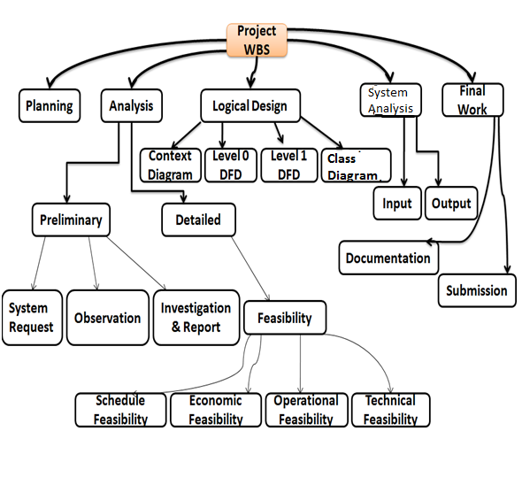

Pert chart
A PERT chart is a project management tool used to schedule, organize, and coordinate tasks within a project. PERT stands for Program Evaluation Review Technique, a methodology developed by the U.S. Navy in the 1950s to manage the Polaris submarine missile program. A similar methodology, the Critical Path Method (CPM) was developed for project management in the private sector at about the same time.

Pert Chart For The Entitled “Library Management Sytem”
ACTIVITY | PREDECESSOR | DURATION(days)
A – Introduction | - | 03
B – System Analysis | A | 08
C – Problem found | B | 03
D – Recommendations | B | 10
E – Selection of Methodology | C | 25
F – Feasibility Report | E | 05
G – Logical Design for System | F | 15
H –DFD for System | G, D | 06
I – Context Diagram | J | 05
J – Overall Documentation | I,H | 04

The PERT chart is sometimes preferred over the Gantt chart, another popular project management charting method, because it clearly illustrates task dependencies. On the other hand, the PERT chart can be much more difficult to interpret, especially on complex projects. Frequently, project managers use both techniques.
FISHBONE / ISHIKAWA DIAGRAM

MUST FILL UP MORE FORM
DOCUMENTATION PROBLEM

COMPILATED TO CHECK BACK THE BOOK ORDER
ANY OWN MUST FILL UP FORM TO PURPOSE BOOK
TAKE TIME
PROBLEM WITH MANUAL SYSTEM
SECURITY PROBLEM
NEED MORE FILE FOR DOCUMENTATION
COMPLICATED TO CREAT
THE SLOW PROCESS TO BOOKING BOOK
MUST DIRECT TO THE COUNTER ONLY
SYSTEM TRADITIONAL MUST FILL FORM
WAIT FOR QUEUE
SYSTEM SLOW BECAUSE MUSH FILL UP FROM
SLOW RETRIEVAL OF NEEDED BOOK.

BACKUP AND RECOVERY
PROBLEM
SECURITY AND INTEGRITY PROBLEM.

DFD
&
CLASS DIAGRAM

Data Flow Diagram

Context Diagram

Level 0 DFD

Level 1 DFD (Book)

Level 1 DFD (Student)

Level 2 DFD

Class Diagram

7.7 Activity Diagram

7.8 Sequence Diagram

Use Case Diagram

Entity Relationship Diagram
There are basically 3 things which we consider while making ERD.
ENTITY
An entity is something, real or abstract, about which we store information. For our system there are basically these 3 entities:
- Librarian
- Student
- Book
RELATIONSHIP
A relationship is an association that exists among entities. For our system we have following relationships among 3 specified entities:
  - One Librarian can register many Students (0:N)
  - One Librarian can add many Students (0:N)
  - One Librarian can search many Students (0:N)
  - One Librarian can delete many Students (0:N)
  - One Librarian can edit information of many Students (0:N)
  - One Student can search many books(1:N)
  - One Librarian can add many books (0:N)
  - One Librarian can search many books (0:N)
  - One Librarian can delete many Students (0:N)
  - One Librarian can edit information of many Students (1:N)

ATTRIBUTES
A property of an entity or a relationship type, for our system we have following attributes of 3 specified entities:
Student: Id of Student, Name of Student, Course, Code of Book Issued, Issue date, Return date, Fine
Librarian: Username and password.
Book: Book code no, Book title, Author of book, No of copies/quantity of books, book status, book price
.
ER-diagram of Library Management System.
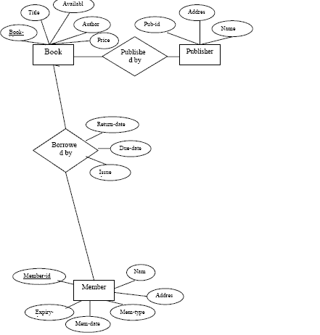
Data Dictionary

A data dictionary, or metadata repository, as defined in the IBM Dictionary of Computing, is a "centralized repository of information about data such as meaning, relationships to other data, origin, usage, and format".[1] Oracle defines it as a collection of tables with metadata. The term can have one of several closely related meanings pertaining to databases and database management systems (DBMS):
- A document describing a database or collection of databases
- An integral component of a DBMS that is required to determine its structure
- A piece of middleware that extends or supplants the native data dictionary of a DBMS
System : Library Search Online | Date : October
Label : Social Security Number | Order : Online Booking Book
Type and Length : 9N | Default Value : None
Source : Employee | Acceptable Value : Any Positive Number
Security : IT Department | User Responsibility : IT Department

SCREEN LAYOUT

Login Form
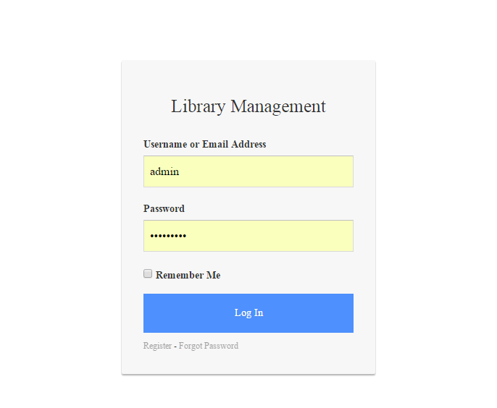

DashBoard Form
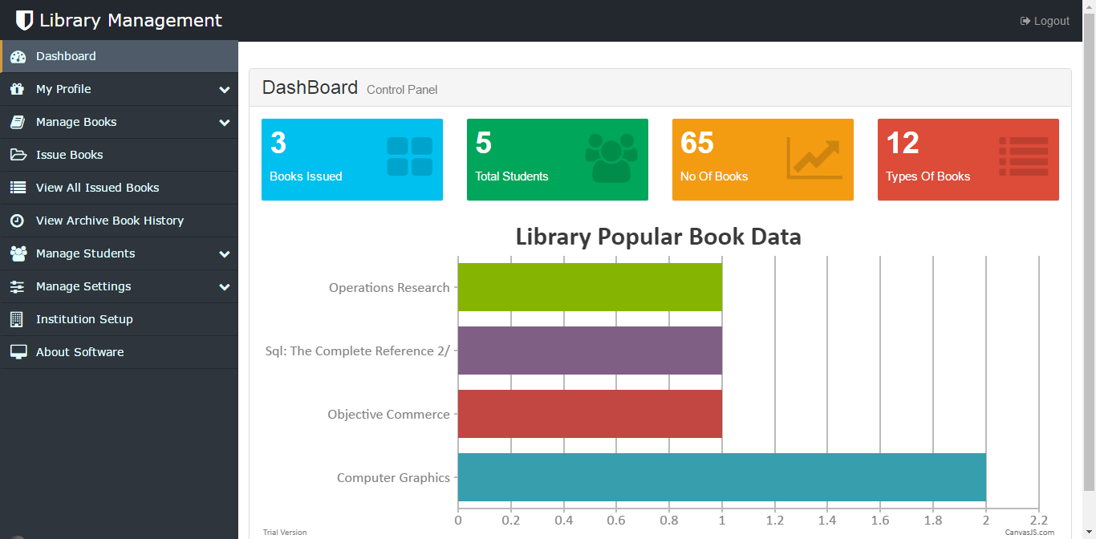
Change Password Form
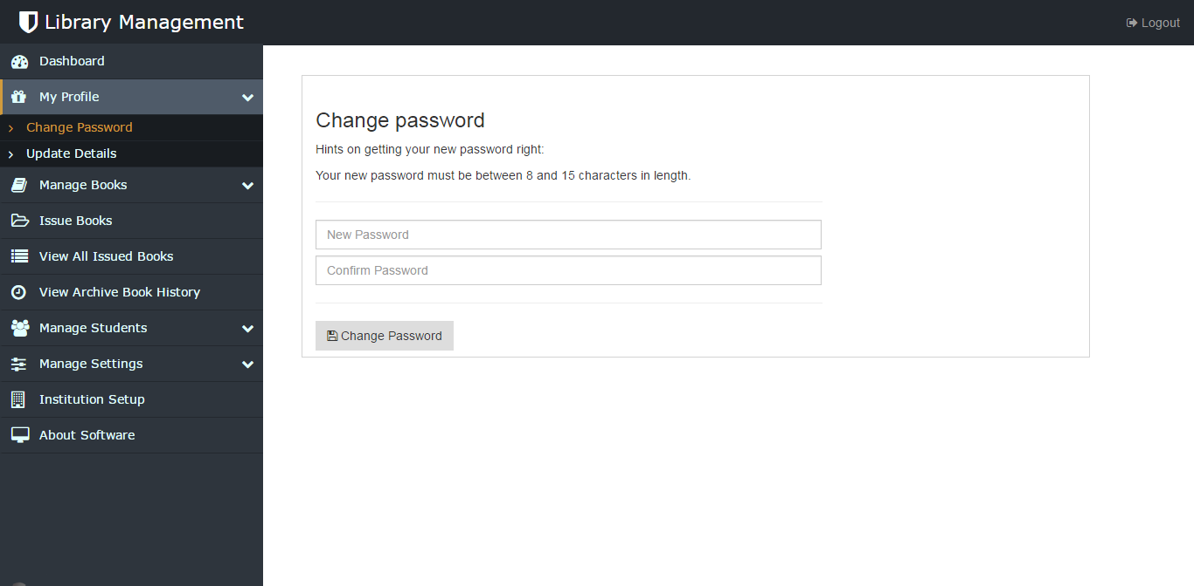

Librarian Profile Update
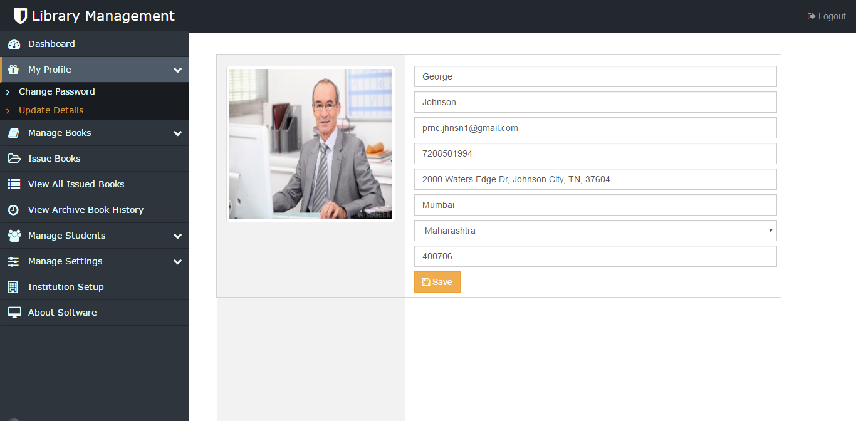

Add Book Form
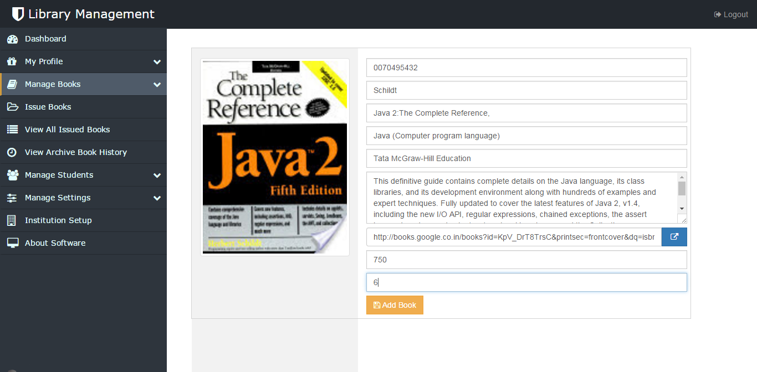

Book Management Form (a)
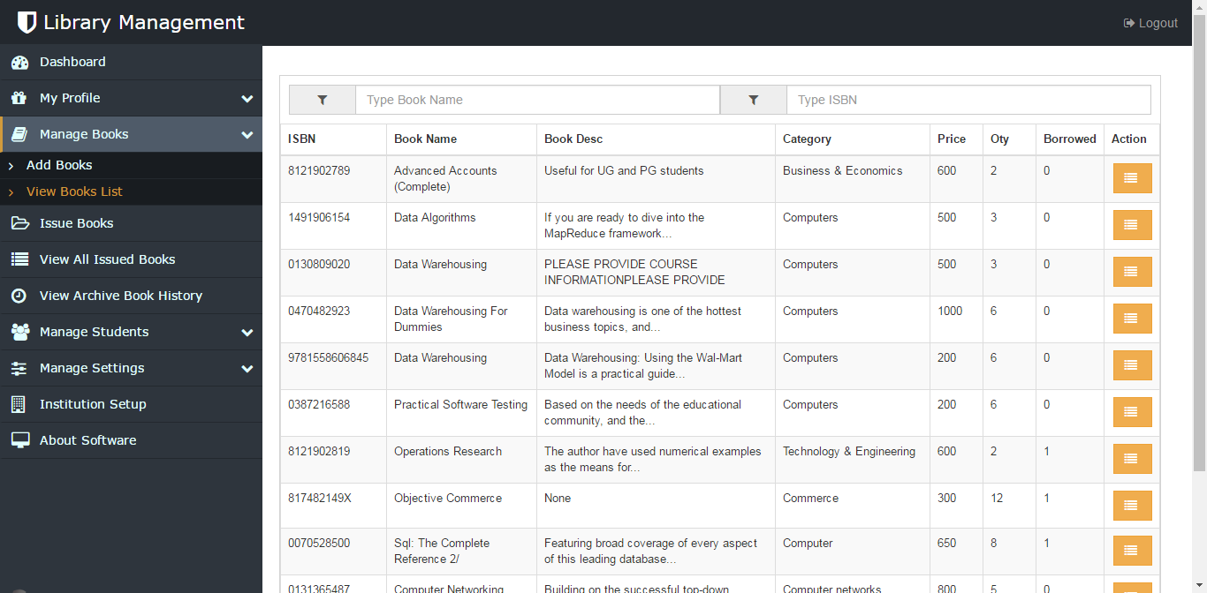

Book Management Form (b)
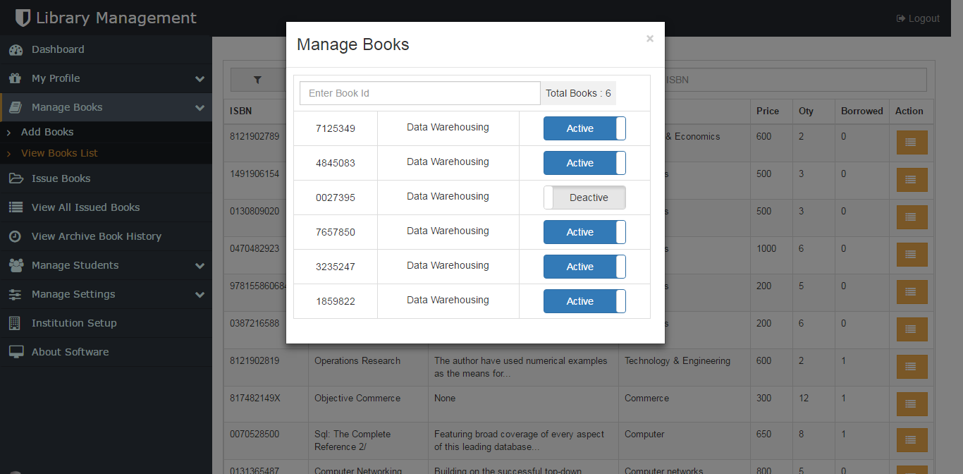

Issue Book Form

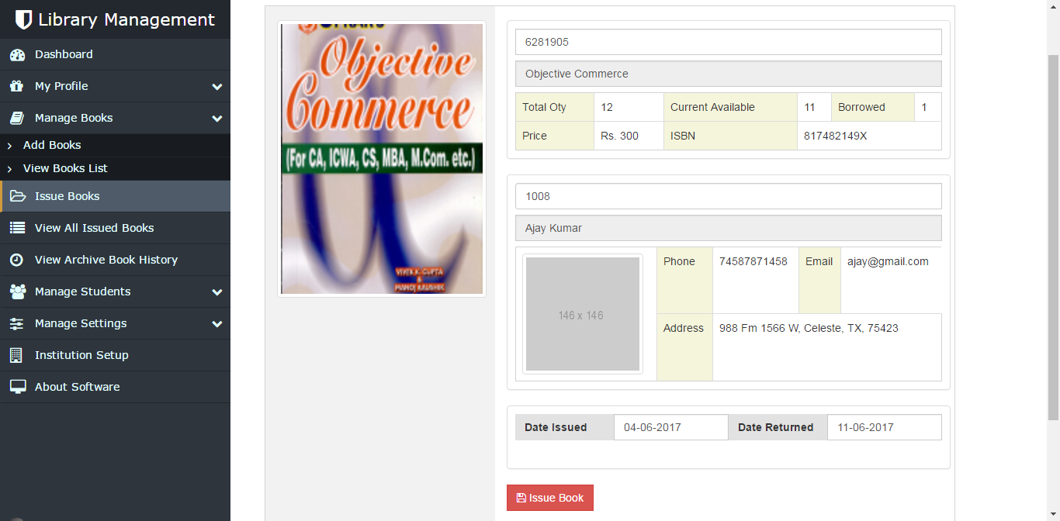

View All Issued Book Form

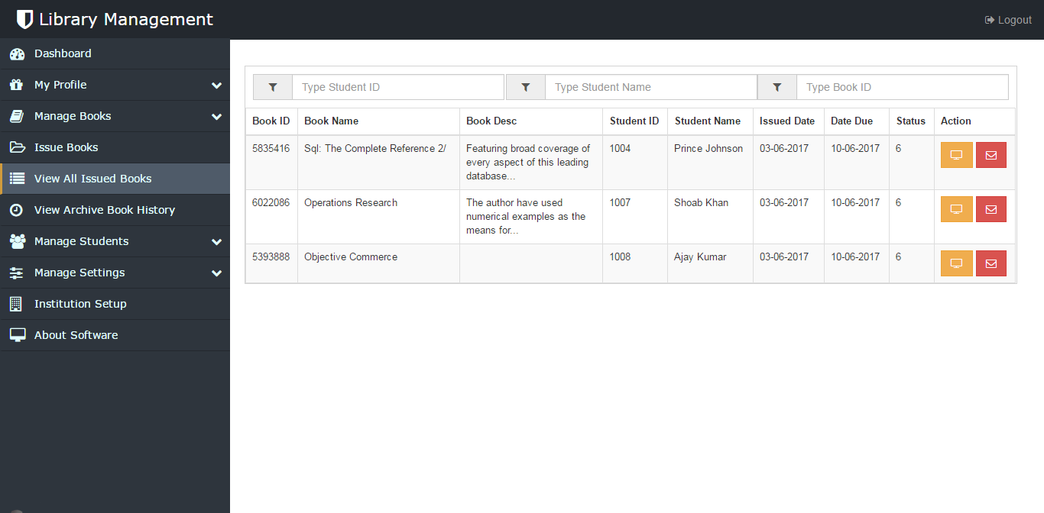

Return Book Form
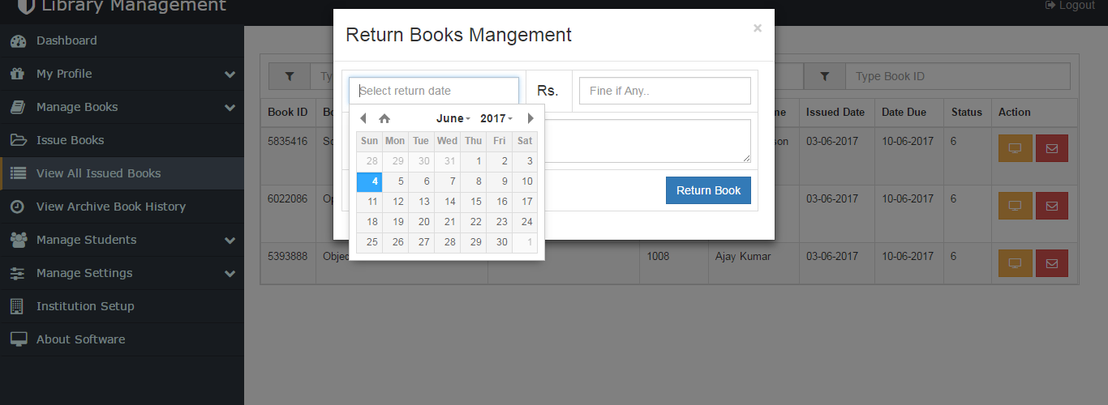

SMS Sending Form
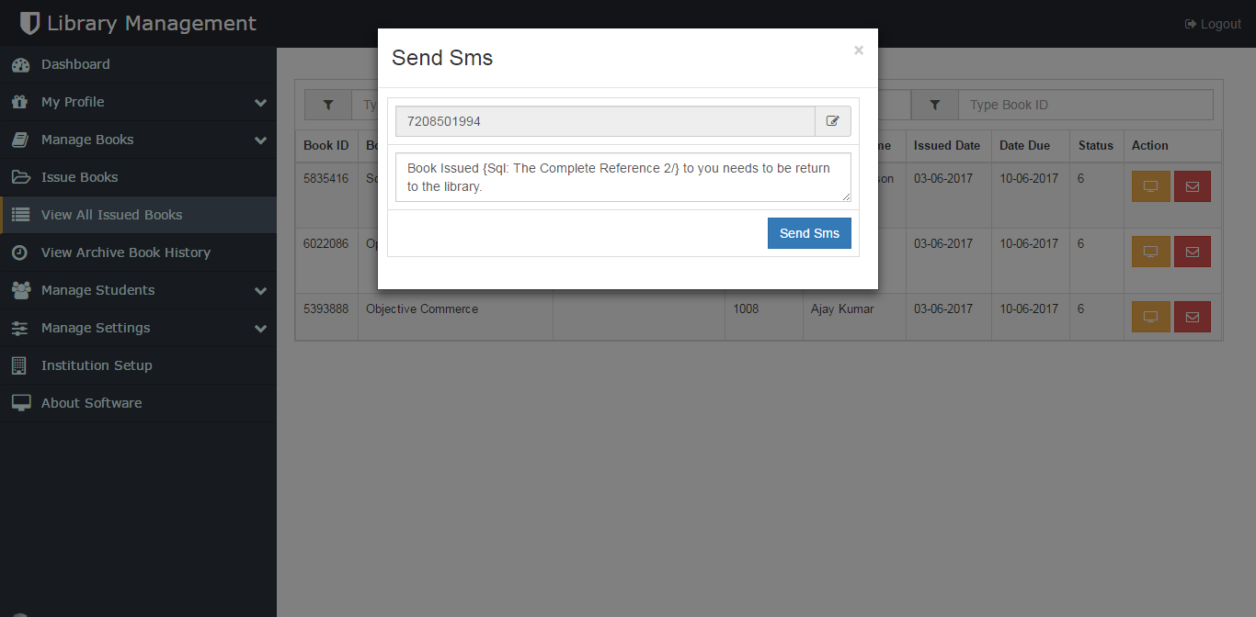

Archive Book History
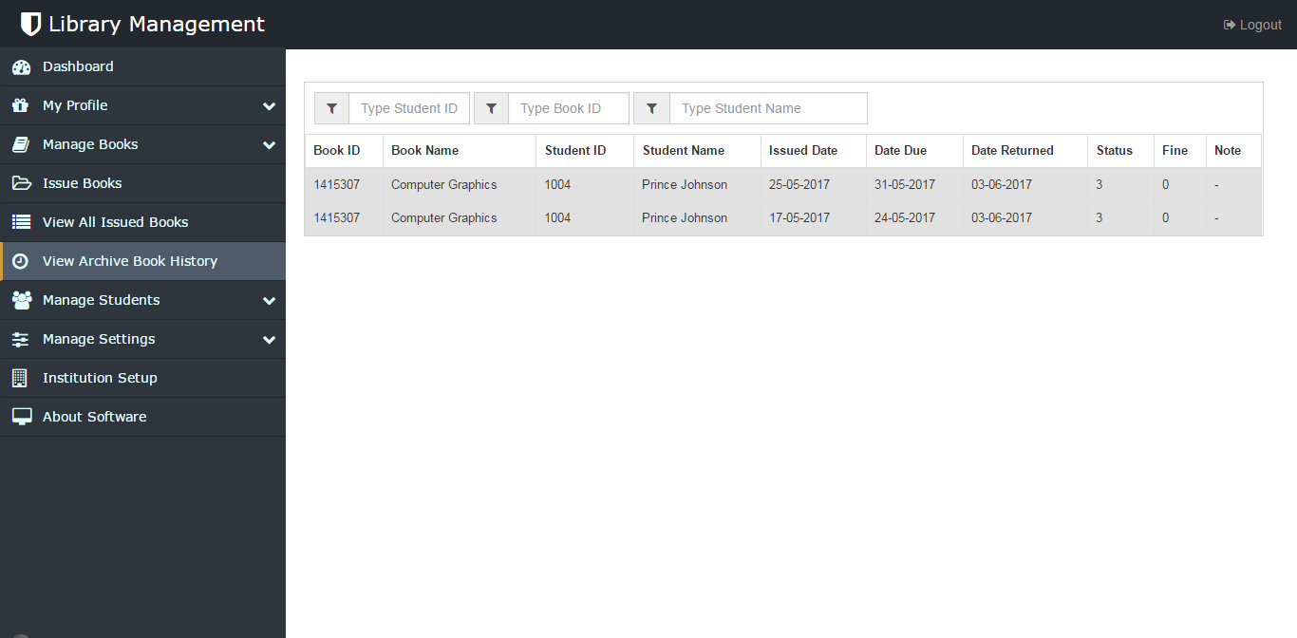

View All Student Form
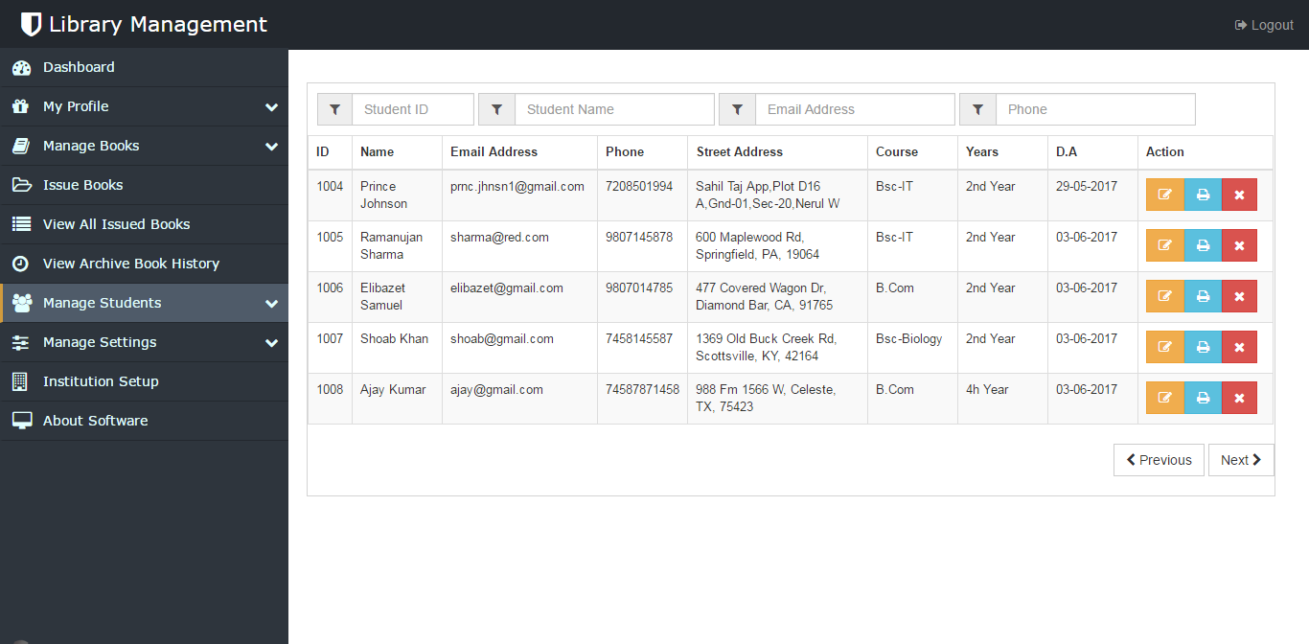

Library Card Print Form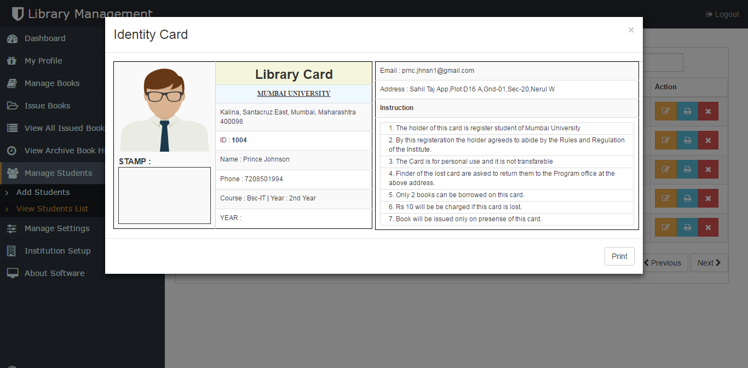
Manage Course Form
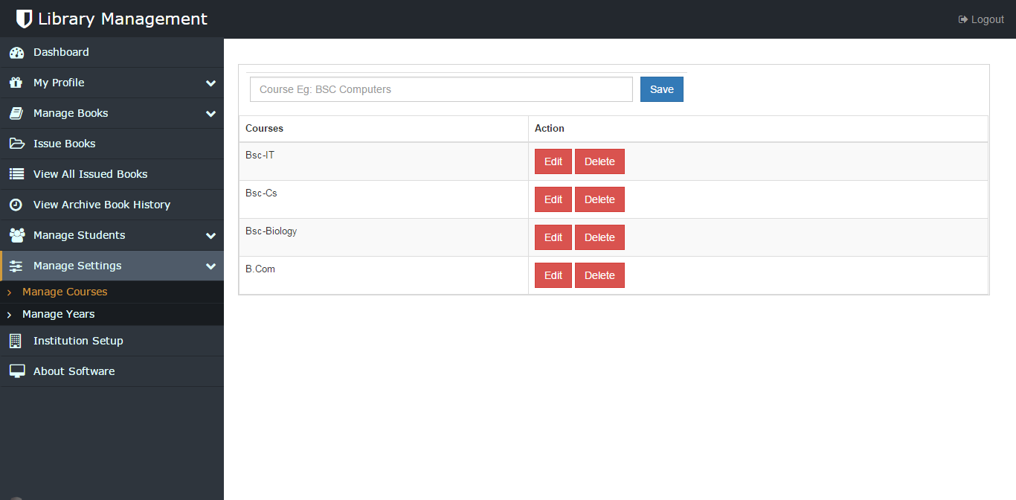

Manage Years Form

Student DashBoard
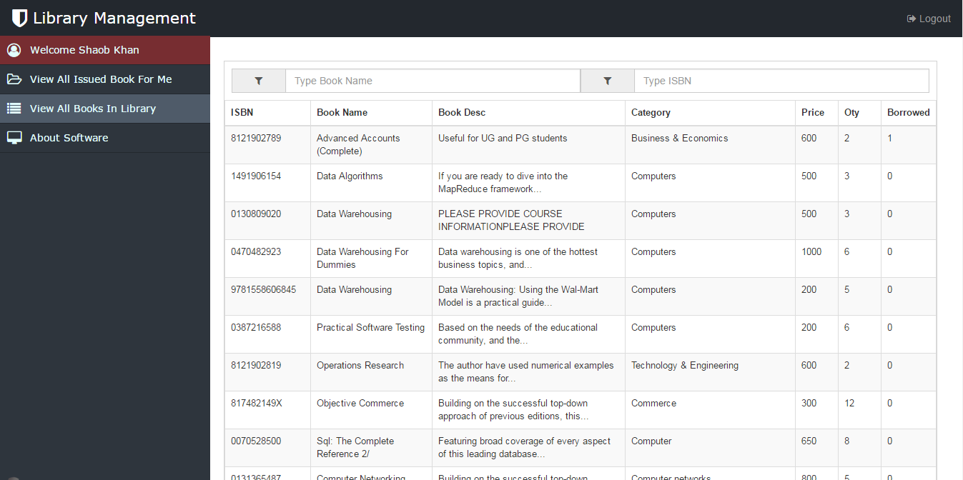

Student Issued Book
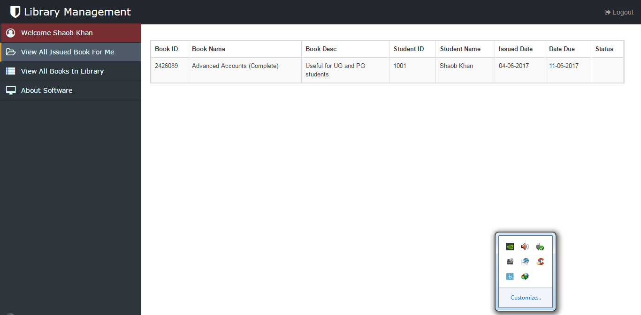

CODING

Add Some Source Code

TESTING

SYSTEM TESTING
The aim of the system testing process was to determine all defects in our project .The program was subjected to a set of test inputs and various observations were made and based on these observations it will be decided whether the program behaves as expected or not. Our Project went through two levels of testing
1. Unit testing
2. Integration testing

INTEGRATION TESTING
In this type of testing we test various integration of the project module by providing the input .The primary objective is to test the module interfaces in order to ensure that no errors are occurring when one module invokes the other module.

UNIT TESTING
Unit testing is undertaken when a module has been created and succesfully reviewed .In order to test a single module we need to provide a complete environment ie besides the module we would require
• The procedures belonging to other modules that the module under test calls
• Non local data structures that module accesses
• A procedure to call the functions of the module under test with appropriate parameters Unit testing was done on each and every module that is described under module description of
Test For the Admin/Librarian module:
- Testing admin login form-This form is used for log in of administrator of the system.In this we enter the username and password if both are correct administration page will open other wise if any of data is wrong it will get redirected back to the login page and again ask for username and password.
- Student account addition- In this section the admin can verify student details from student academinc info and then only add student details to main library database it contains add and delete buttons if user click add button data will be added to student database and if he clicks delete button the student data will be deleted.
- Book Addition- Admin can enter details of book and can add the details to the main book table also he can view the books requests.
Login Screen

Step  No | Test Step | Expected  Result | Actual Result | Test  Result
1 | Enter a  username and password (a correct password but wrong username | An error  showing  “Username  & password mismatch | Nothing actually popped up  and the authentication seemed succesful. | FAIL

2 | Click on the  Add book button. | A pop up  should appear  book added succefullyy |  | PASS

CONCLUSION
This website provides a computerized version of library management system which will benefit the students as well as the staff of the library. It makes entire process online where student can search books, staff can generate library cards and do book transactions. It also has a facility for student login where student can login and can see status of books issued.

This system has been developed in a way to make it very user friendly.Any person having a basic understanding of computer can run this system without any pain.

The system is strong enough to withstand regressive yearly operations under conditions where the database is maintained and cleared over a certain time of span. The implementation of the system in the organization will considerably reduce data entry, time and also provide readily calculated reports.
The problems, which existed in the earlier system, have been removed to a large extent. And it is expected that this project will go a long way in satisfying users requirements. The computerization of the Library Management will not only
improves the efficiency but will also reduce human stress thereby indirectly improving human recourses.
This project is very useful in managing the record and other operation of library.
Moreover this project can be upgraded and changed according to the need of user.

Thank you !
Contact Us: Random Name @gmail.com

BIBLIOGRAPHY
This refers to the books/websites which were gone throught for completion of this project reports.
SOME BOOKS REFERED
- System Analysis & Design – Senn
- Software Enginneering – Pressman
- System Analysis & Design – Elias Award
- Angular Js Complete Reference

SOME WESBITES REFERED
- http://www.gobookee.com/library-management-system-er-diagram-and-dfd/
- http://www.gobookee.com/get_book.php?u=aHR0cDovL3d3dy5rZGQudW5jYy5lZHUvQ3ludGhpYS8zMTYwUHJvai9SZXBvcnRfRmluYWwucGRmCkxJQlJBUlkgTUFOQUdFTUVOVCBTWVNURU06IERFU0lHTiBBTkQgSU1QTEVNRU5UQVRJT04=
- http://www.scribd.com/doc/24051771/UML-DIAGRAM-OF-LIBRARY-MANAGEMENT-SYSTEM
- http://www.evalued.bcu.ac.uk/tutorial/4c.htm
- http://wiki.answers.com/Q/What_are_the_advantages_and_disadvantages_of_observations
- http://www.softaiminnovations.com/web/index.php?option=com_content&view=article&id=8&Itemid=9 http://www.umsl.edu/~sauterv/analysis/488_f01_papers/wang.htm
- http://www.dba-oracle.com/t_object_oriented_approach.htm
- http://coursesweb.net/actionscript/oop-object-oriented-programming
- http://www.brighthub.com/internet/web-development/articles/73920.aspx?cid=parsely_rec
- http://www.ehow.com/list_6781448_advantages-disadvantages-ssadm.html

